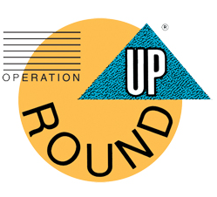Operation Round Up

Minnesota Valley members have the opportunity to participate in the Operation Roundup program, which provides financial assistance to area communities and families in need.

By participating in this program, members allow the cooperative to round up their monthly electric bill to the nearest dollar. For example, if your actual electric bill is $72.50, we will round it up to $73.00 and the extra 50 cents goes into the Operation Round Up Fund. With this method of donating, the most you could donate in a year would be $11.88 per account, but the average is $6.00.

It’s easy to become part of this great community service program. Simply call the Billing Dept. at 320.269.2163 or 800.247.5051 or check the box of your next energy payment stub to let us know you want to begin contributing to Operation Round Up.

In addition, if you are participating in Operation Round Up and you find your location number in the monthly newsletter, your energy bill will be credited $20 instead of the usual $10.

Although your monthly contribution seems small, when it’s combined with the contributions of other members, it amounts to big help for those in need. So join today to begin helping us help meet the needs of our area communities.